MOSSLEY COMMUNITY ASSOCIATION
8th Annual ‘Virtual’ Horticultural Show
ALL FOR FUN while in SUMMER ‘LOCKDOWN’
For all entries please e mail a photograph of yourself with your entry to admin@mossleycommunitycentre.co.uk
by 1st September 2020
WITH YOUR NAME and age if under 16
ADULT ENTRIES
VEGETABLE CATEGORIES GROWN IN GARDEN , POT, ALOTMENT OR WINDOWSILL
Longest runner bean - photograph against ruler /tape measure.
Five potatoes (any variety) Grown by you.
Carrots, Onion, Tomato, Leeks Celery ,Lettuce (These can all be grown from the root from your salad drawer if you don’t have a garden).
FRUIT CATEGORIES photograph yourself with your fruit in the garden on the tree /bush
Apples ,Rhubarb ,Berries or any other fruit you are growing.
FLOWER CATEGORY
An indoor flowering pot plant grown by you
Succulent or Cactus
Any flowers in your own garden.

FLORAL ART CATEGORY
Design a floral display to thank key workers using real or artificial flowers with one ‘prop’ of your choice. This could be for NHS , Carers, refuse collectors , Supermarket staff, or anyone you feel deserves a thank you for their efforts during this pandemic .
HOME BAKING CATEGORY
Your favourite ‘Lockdown ‘cake ’ that you love and that is getting you through isolation with recipe and photograph.
ADULT ARTY CRAFTY CATEGORY
Send us a photo of something you have made to help others in Lockdown.
It might be a mask scrubs, bags , hearts, NHS teddy or something else. Send us a photo and who it was made for.
We want you to show us what you’ve made with a ‘Rainbow’ colour theme as a thank you and tribute to the front line workers. Any medium.
So paint , sewing , knitting, Crochet glass or anything else you have.
PHOTOGRAPHY CATEGORY
ART RECREATION Using only what you have in your house, garden, and wardrobe recreate ANY famous painting. Use you famiy, pets and anything you can find as props. Send us your photo along with the famous painting you are recreating. SEE EXAMPLE BELOW.
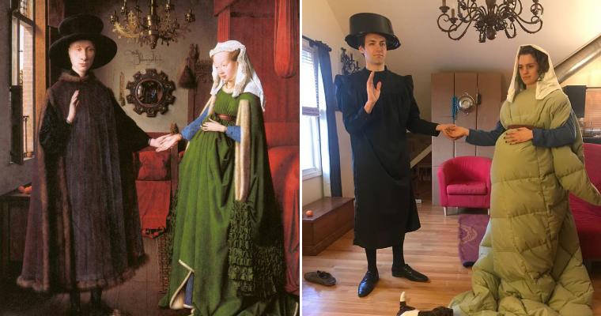

CHILDRENS ENTRIES
YOU’VE MADE IT, SHOW US. ANYTHING GOES!
Have you made something you are proud of? We want to see it. Send us a photo of you and your amazing ‘lockdown’ make. Include your Name and age.
POEM
Write a poem about ‘Lockdown’ life.
YOUNG COOKS
Make a trio of decorated biscuits or buns with a Rainbow, bee and flower design.

